**The Austin Galbis Wish You and Yours Holiday Happiness!**

 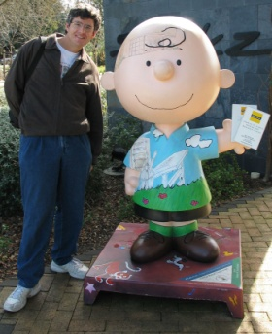

Not as bad when in Paradise Visiting Old Friends in California

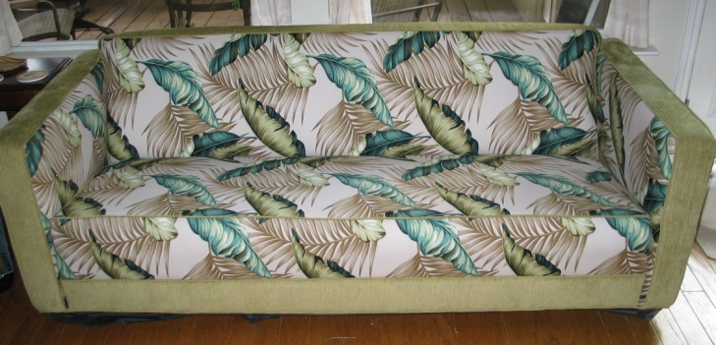 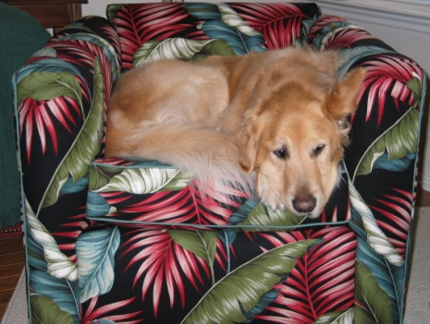

Tamara’s Upholstery Hobby Continues Her Best Customer

  

The Gorras invade Texas And Dance the Night Away Our New Nephew – Paul Gipson

  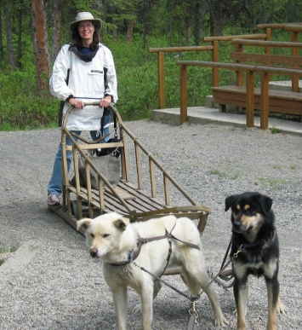 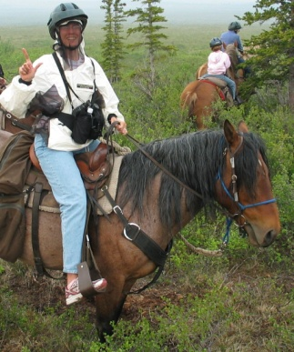

Cruising… Climbing… Sledding… And Riding through Alaska

### May the New Year bring Peace and Joy to All!

### dwightgalbi@hotmail.com tamaragal@hotmail.com