**A Holiday Hello from the Austin Galbis**

  

Texas Winter – One Day Dwight’s 40th – Staying young w/cousins… and his 12-yr Companion



Tamara’s Dad, Gibbs Milliken: 1935 – 2007

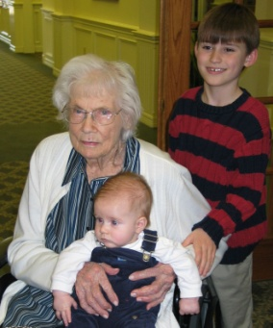   

Mam-ma w/Great Grandkids Guess Who? Still Perfecting the Swing T’s new job w/travel to Paris

  

Cruising the Caribbean Award-winning “boat” Another year sets

### We Wish You Peace, Health, and Happiness in the New Year

### dwightgalbi@hotmail.com tamaragal@hotmail.com