**Happy Holidays from the Austin Galbis!**

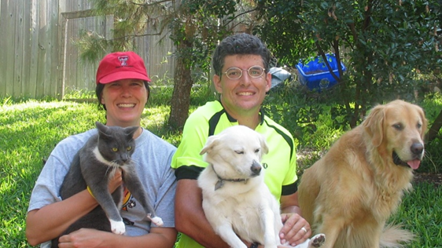 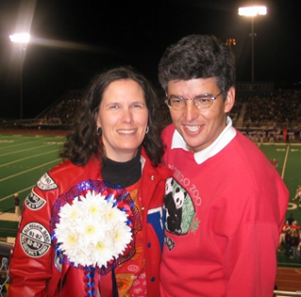

The Family Portrait (Minus 2 Cats) WHS Homecoming

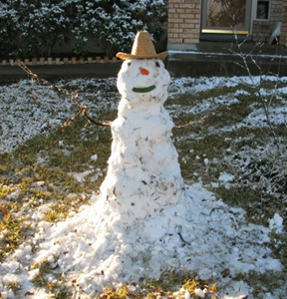 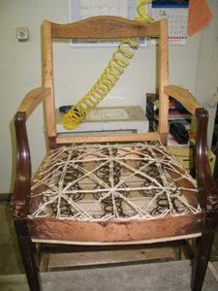 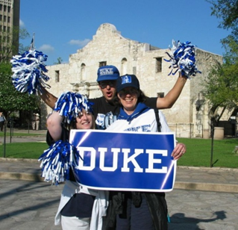

#### **Texas Snowman Upholstery Work Final Four**

#### **Valentine’s Day by Tamara San Antonio**

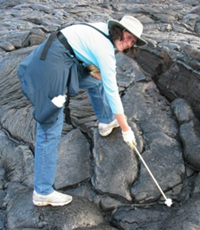 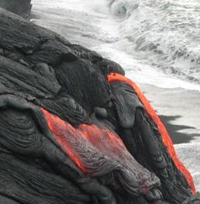 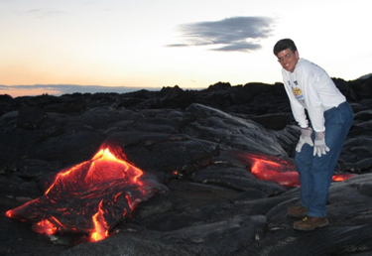

**Roasting Marshmallows on the Lava “Ooze” in Hawaii**

**We wish you and yours all the best in the New Year!**

**dwightgalbi@hotmail.com tamaragal@hotmail.com**