Wishing you and yours the happiest of holidays – The Austin Galbis

  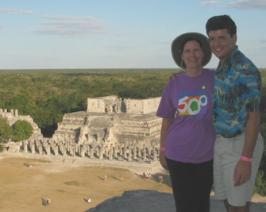

1st Visit to Yankee Stadium Dwight’s 20th High School Reunion On top of Chichen-Itza

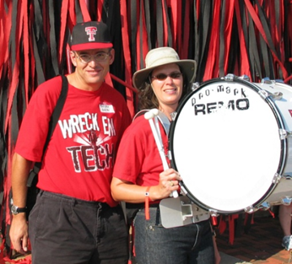  

Tamara’s Band Reunion Dwight’s golf struggles continue Tamara relaxes with sister and nephew

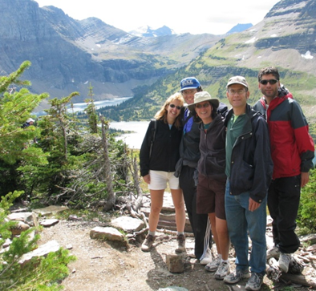 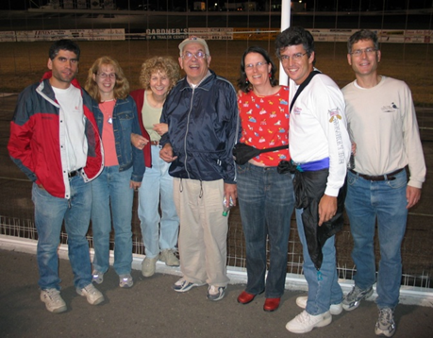

Galbi Family Reunion in Montana covers glacier climbing to car racing

### We hope the New Year brings peace and joy to all!

### dwightgalbi@hotmail.com tamaragal@hotmail.com