**Holiday Greetings from the Austin Galbis**

**  **

**Celebrating 15 yrs of Love At Our Home Away from Home Time for One More Hole Dear?**

**  **

**Tamara Serves As Delegate While Dwight Changes Jobs 75th Birthday Bash for Tam’s Mom**

**  **

**Tam’s New Love - Sabrina Mama with Some of the Grandkids Tygar and Curby Take a Break**

 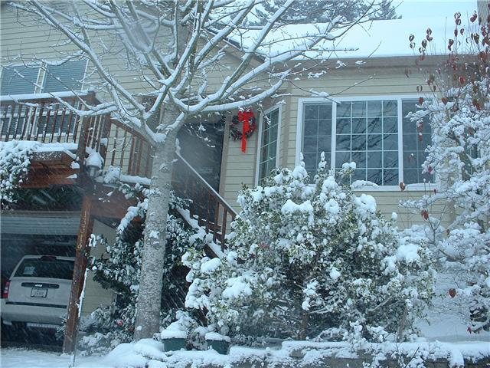 

**December Texas Snow Our Holiday Destination – Oregon A Hui Hou Kakou – Til We Meet Again**

**We hope the New Year Brings Peace, Health, and Happiness to You!**

**dwightgalbi@hotmail.com tamaragal@hotmail.com**