**Happy New Year from the Austin Galbis**

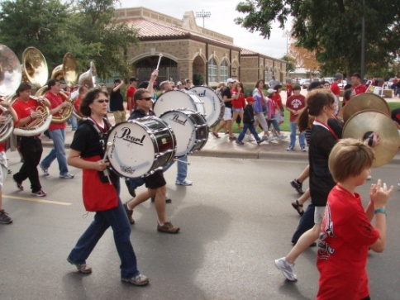 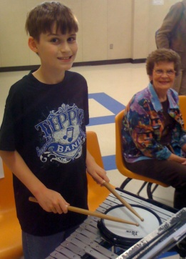 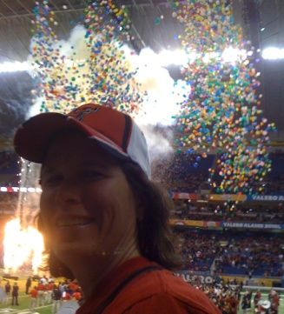 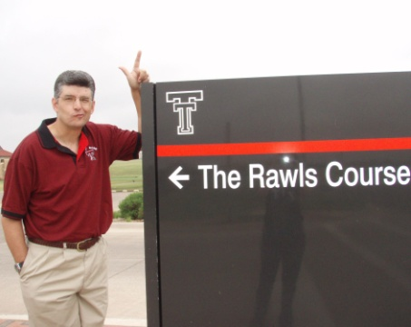

**Tamara Drums It Up at Texas Tech Nephew David Follows Tech Bowl Victory What – No Golf??!!**

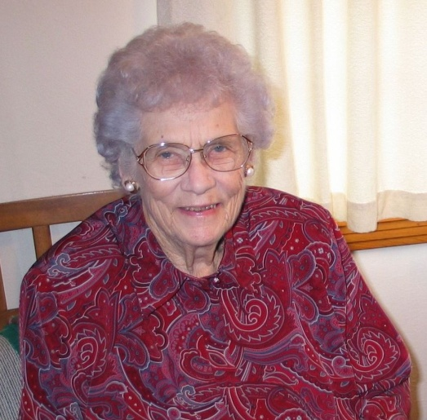

**Tamara’s Mam-Ma – Resting in Peace after 94 wonderful years**

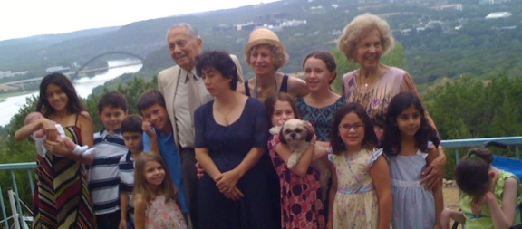 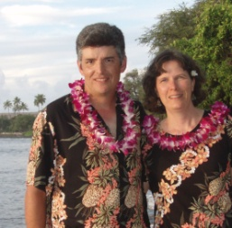 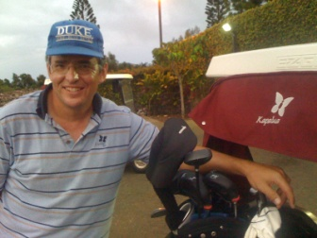 

**Birthday Fun with the Shias 16th Anniversary End of a rough day Gorra Reunion in Oregon**

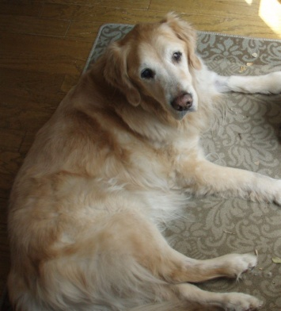 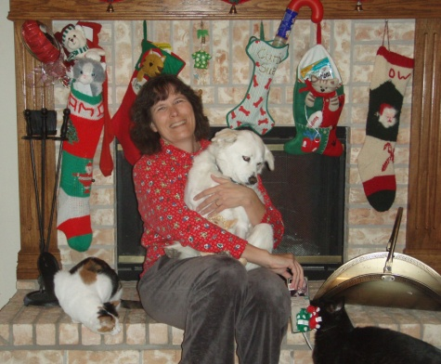  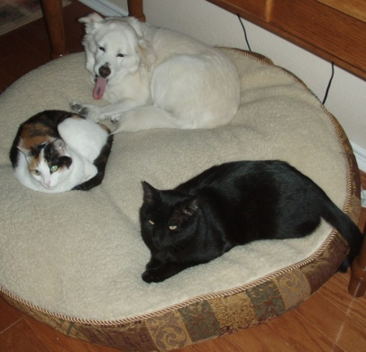

**Tygar – Gone, not Forgotten Christmas with our Crew Spinning under the tree Naptime: Sabrina,Curby,Maestro**

**We hope the holidays brought joy for you and your family!**