**Happy Holidays from the Austin Galbis**

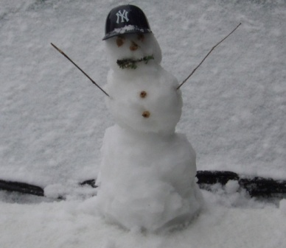 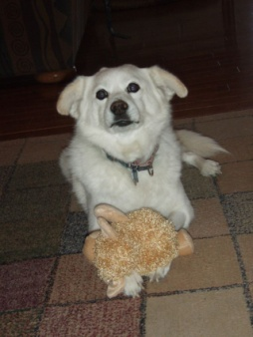 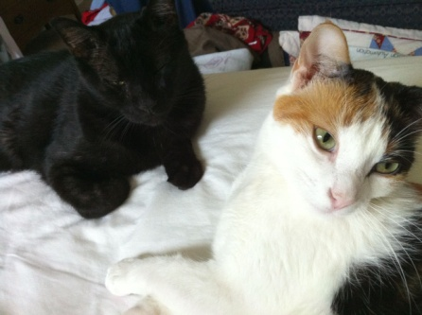 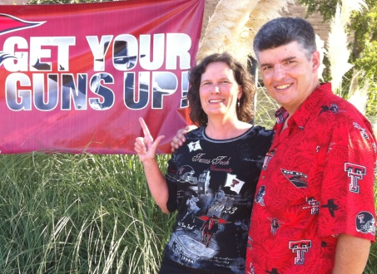

**Texas Snowman in Feb Curby – R.I.P. Maestro and Sabrina Texas Tech Band Alumni Day**

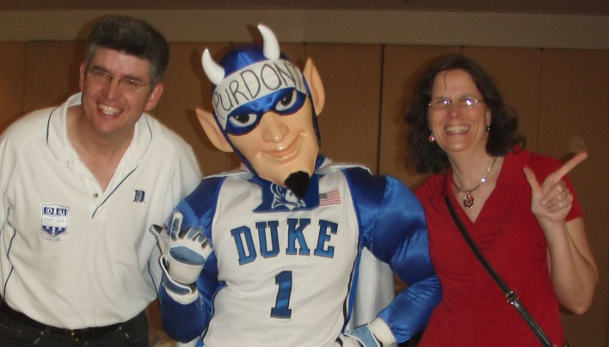 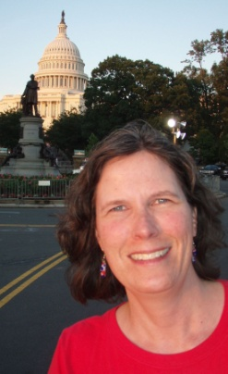 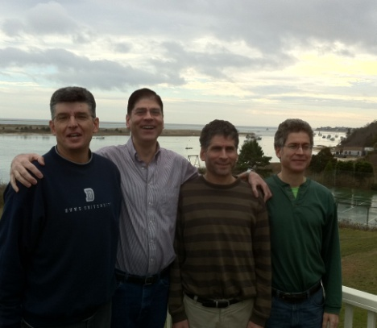

**Duke B-Ball in Houston on way to becoming champs! 4th of July in DC Thanksgiving at Cape Cod**

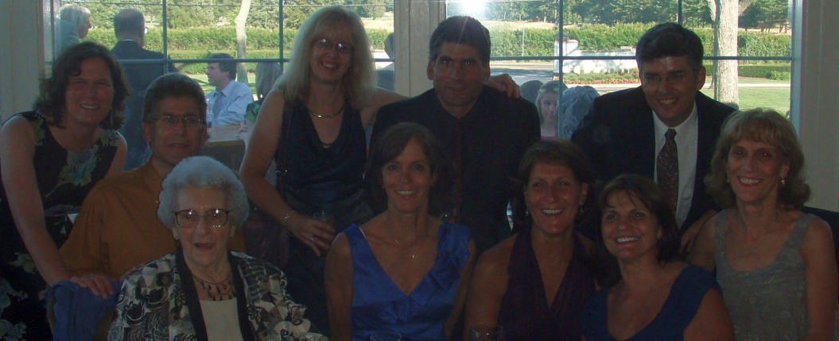 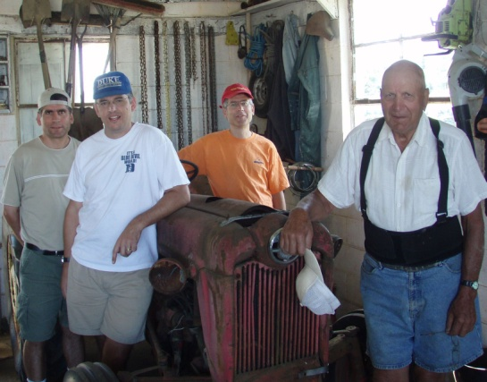

**Reuniting with relatives at cousin Walsh’s wedding in New Jersey Uncle Arnold’s Next Restoration Project** 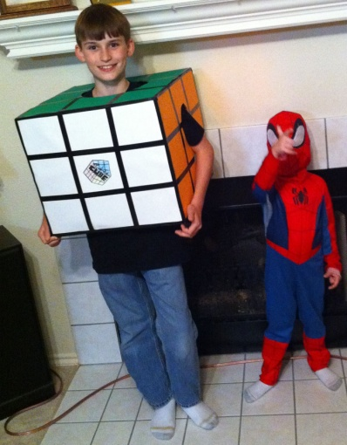 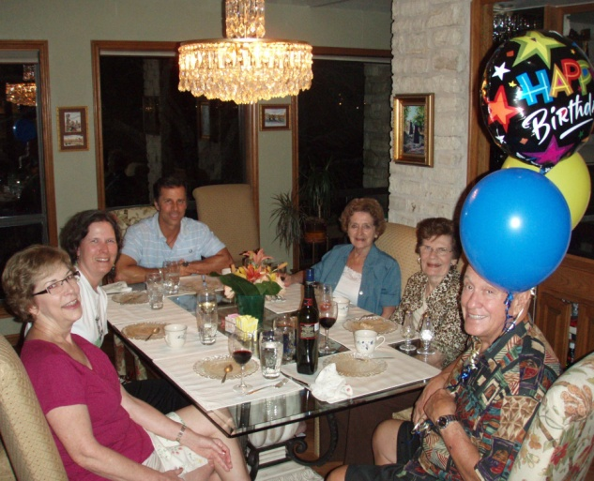 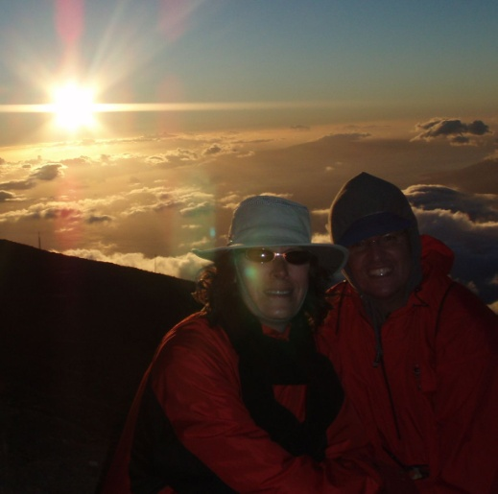

**Nephews in Costume Birthday Fun with “UJ” 17th Anniversary Sunset at Haleakala**

**Best Wishes for the Holidays and a Happy New Year!**