**Two Years of Happy Holidays – Austin Galbis** 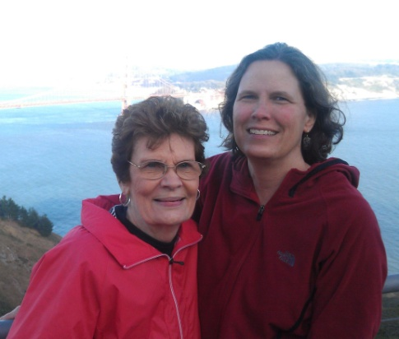 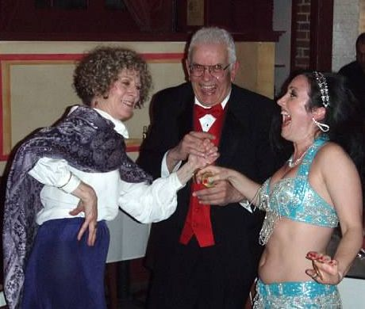 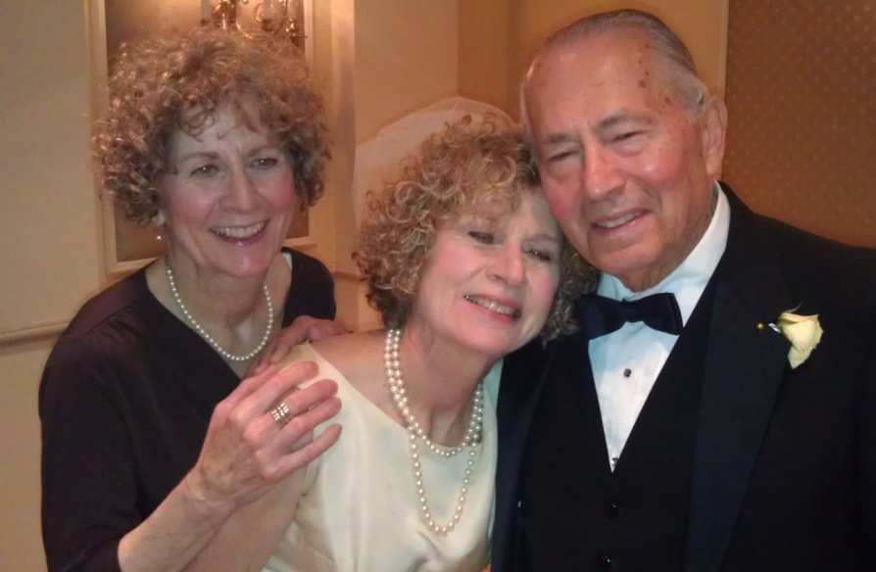

**Tamara & Mom – San Francisco Mom & Dad - 50th years 6 months later – Mom’s Twin Follows 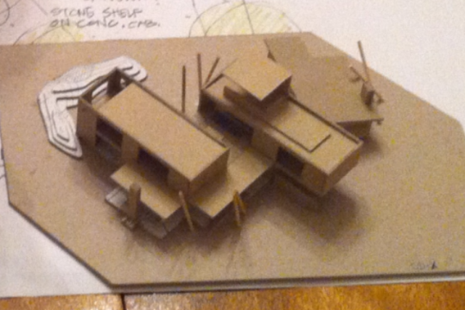 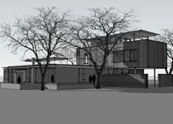 **

**Nephew David New House Design Starts in 2011 Design Development Almost Done in 2012 Nephew Paul**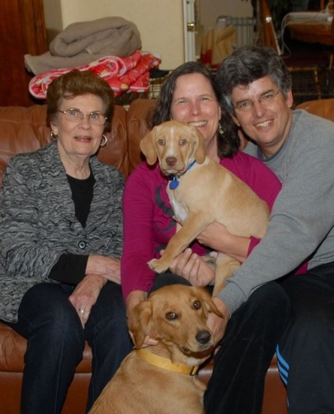 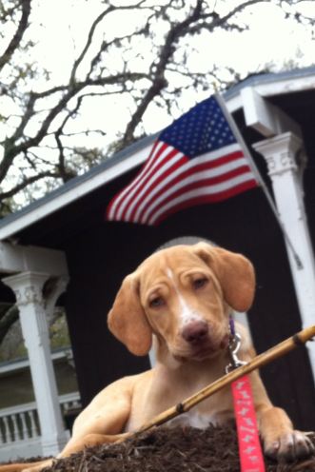 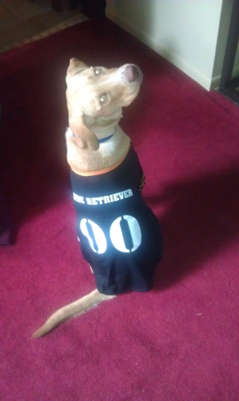 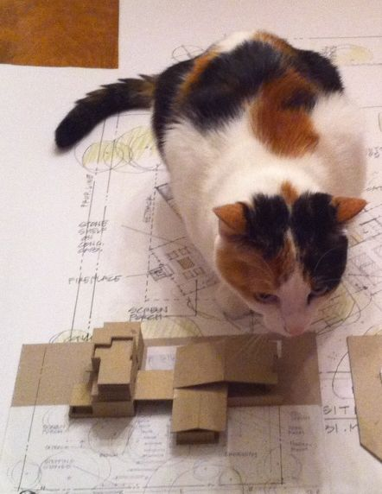

**Teddy (Center) Joins Family Patriotic Pup Halloween Costume Sabrina Studies Early Design**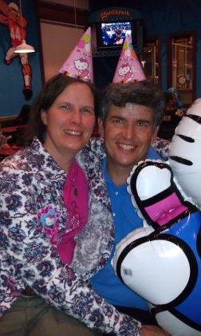 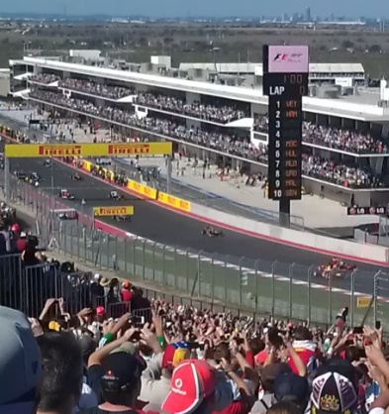  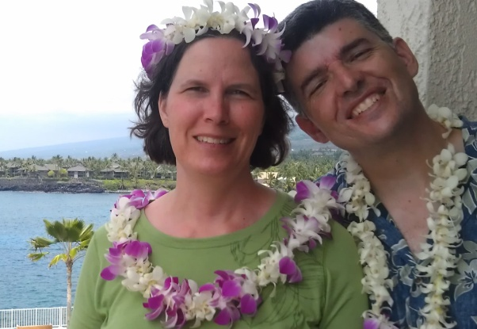

**Hello Kitty Party F1 Racing Comes to Austin Getting Tough? The Aloha Spirit Still Calls Us**

**Hoping the Holidays and New Year Bring Happiness to All!**