**Holiday Wishes To You * 2 years - Austin Galbis** 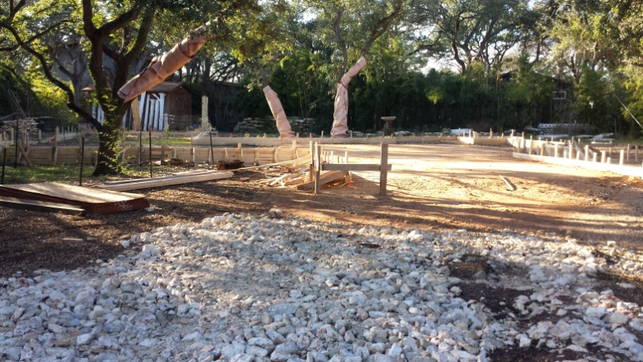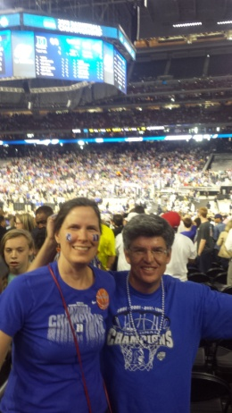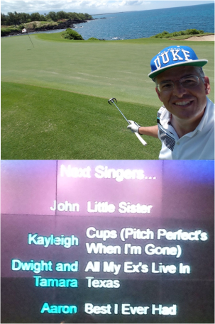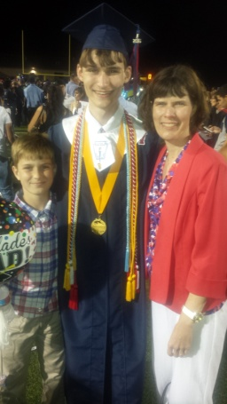

**House Starts Rising in 2015 Duke #1 Again New Careers? Not yet Nephew Graduates**

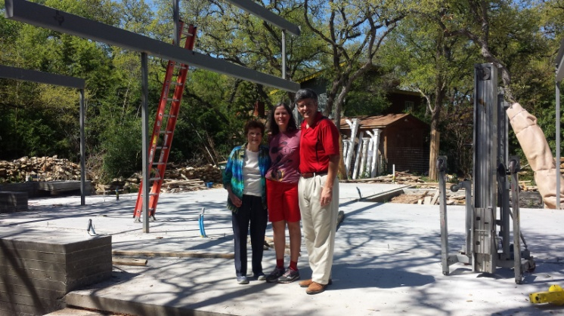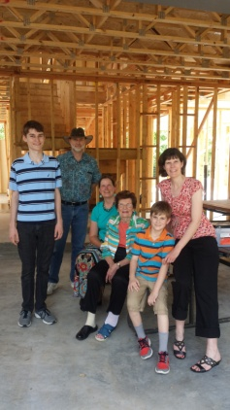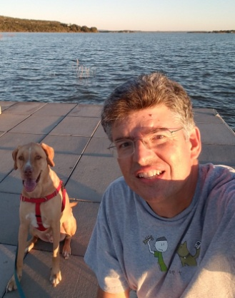 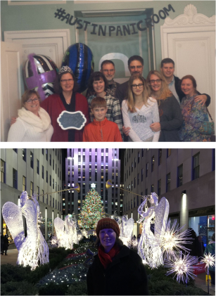

**Foundation and Steel Arrive – Texas Strong of Course Family Gathering Canine Camping Whirlwind B-Day** 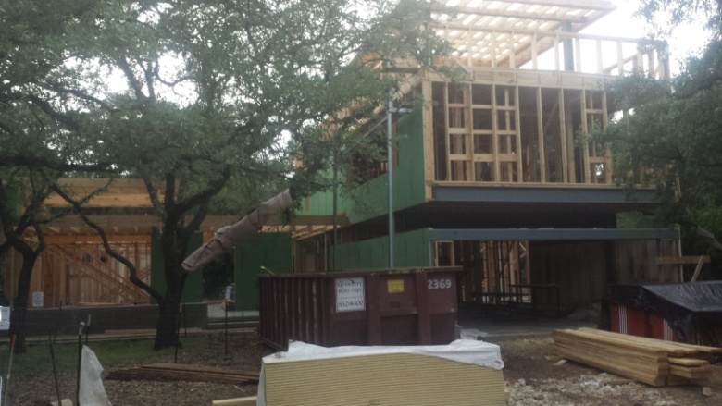 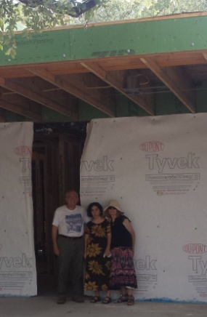 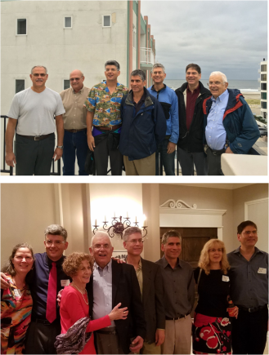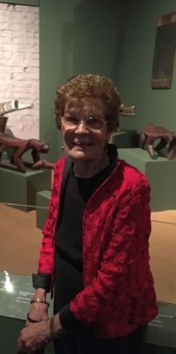

HMNS

**Framing Provides Basic Shape – Then Comes The Details Special Visitors Galbiati Family Reunion Amazon Exhibit**

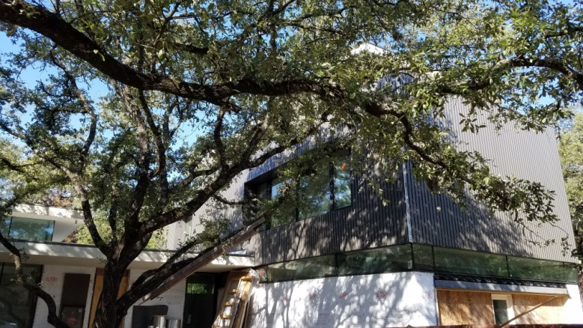 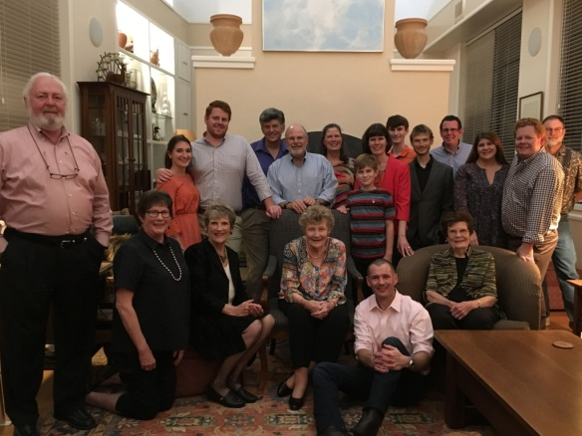 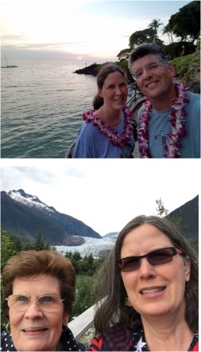 **Not Finished Yet – But Getting Close! Aunt Alice Birthday Celebration Return Visits**

Alaska

**Expecting An Exciting New Year – May Joy Come To All!**