**Holiday Blessings To You - Milliken/Galbi Household**

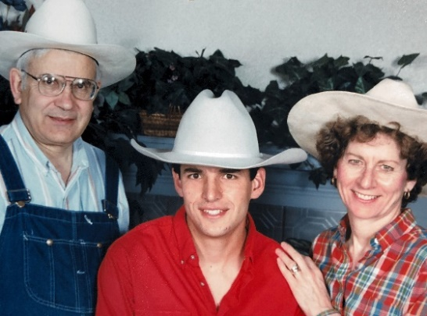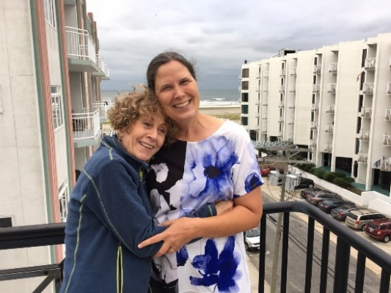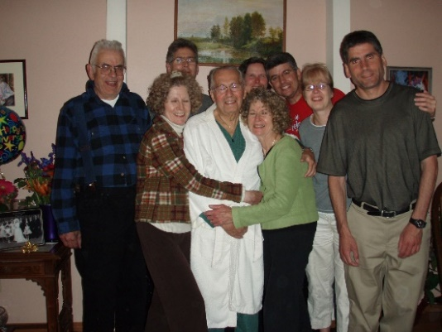

**Cherishing the Memories The Hugs The Fun-filled Gatherings**



**MomG - https://galbimilliken.com/mom-rest-in-peace Uncle George: 90 Blessed Years**

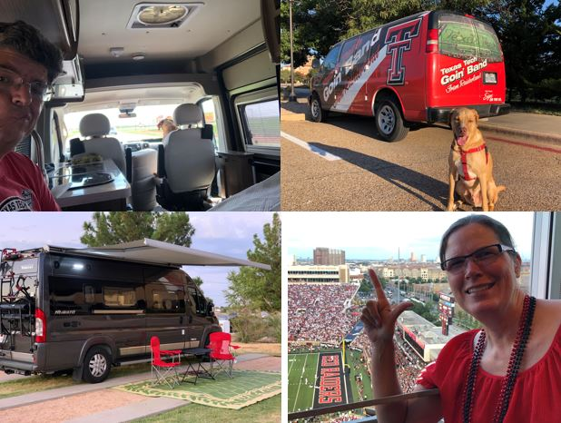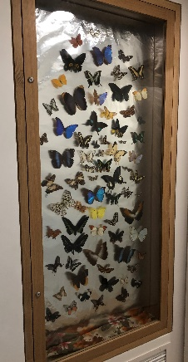  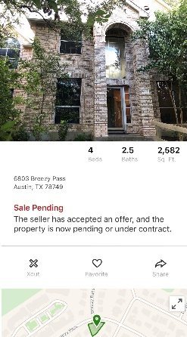

**Return to High School Texas Tech – RV Trial Tailgate Butterflies return w/PGA Marshal Goodbye – 26yrs**

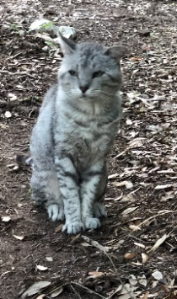 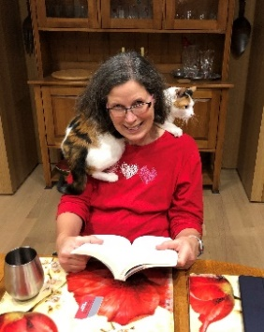 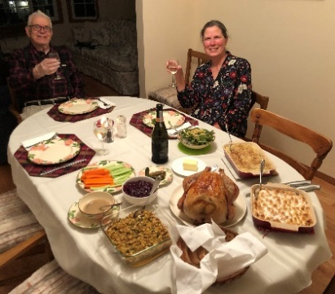 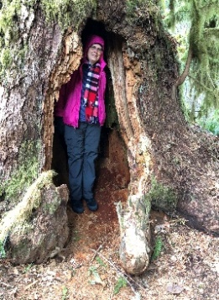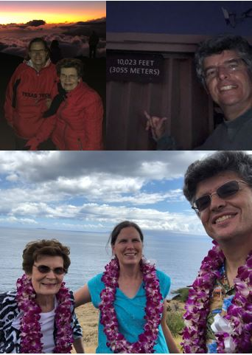 

**RIP – Scrabbles Sabrina Relaxing Thanksgiving in Oregon Introducing MomM to Maui**

**Wishing for Peace and Happiness in the New Year**

[**marimill2@hotmail.com**](mailto:marimill2@hotmail.com)[**tamaragalbi@icloud.com**](mailto:tamaragalbi@icloud.com)[**dwightgalbi@hotmail.com**](mailto:dwightgalbi@hotmail.com)